Feasibility
Analysis

Share Karo! App

Prepared by Share Karo App member
Ishitaa Sayal U101114FCS070 (S3)

TABLE OF CONTENTS

- Executive Summary

- Description Of Products And Services

- Technology Considerations

- Product/Service Marketplace

- Marketing strategy

- References

- Conclusions

EXECUTIVE SUMMARY

The “Share Karo App” is a part of our software engineering project in vth semester III year. This project is prepared by 6 students Ishitaa Sayal: U101114FCS070 (S3), Jharana Shrivastava: U101114FCS073(S3), Jatin Kakkar: U101114FCS072 (S3), Akshay Gupta: U101114FCS039 (S2), Anshul Sharma: U101114FCS046 (S2); Ayushi Jain: U10111$FCS055 (S2).

The admin rights of the app and the first installment presentation lies with the developers and founders of this app. The app has been purely developed by it’s founding members with proper division of workforce.

The app has been designed keeping in mind the interest of students(college/universities) and targets the same. Through thorough research and survey within the college campus, it has been observed how hostellers tend to look out for sharable movies, novels and TV series to watch for entertainment in the leisure time in hostel.
Through surveys have been conducted on college/university students and the results have led to development of the project.
To kinds of surveys have been conducted.
One of the surveys was done to know weather the idea is feasible or not
Another survey was done to know the response of the students towards the app, weather they going to use it or not.

DESCRIPTION OF PRODUCTS AND SERVICES

The project is mainly focused on three features.

Movie Sharing:

The students mainly hostellers indulge in watching movies during their leisure time in hostels. It’s again put in high priority level of the app. Users put up their collection of movies on the app and search for those movies they fell like watching.

Novel Sharing:
The students mainly hostlers indulge in reading in their leisure time. They love to read in order to improve their vocabulary and reading skills. It’s again in a high priority level of the app. User can put up their collection of books on the app and search for the ones they like to read
TV-Series Sharing:
Students mainly hostler indulge themselves in watching TV Series (American). They love to know about what’s happening around the world in get a insight into different kind of lifestyle. They get to know about the lifestyle of people outside their country. The app provides them with option to put up preferred TV Series or the genres they like the most and search what they want to watch.
Study Material Sharing:
Students prefer to get their course ppts and project materials on Internet. Our app provides the facilities to update the reference materials for their juniors. Its put on a low priority level of our app. Students can also search for the reference materials they require uploaded by their seniors
Conveyance Sharing:
Students prefer to share a cab to a common destination in order to reduce the travel cost. It’s again put up in a low priority level of the app. Students can put their travel details like date and time of journey and destination and search for the users travelling around same time. This would provide them with a option to share the conveyance.
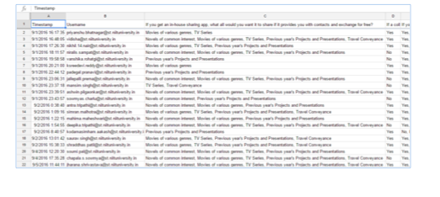
list of responses of second survey

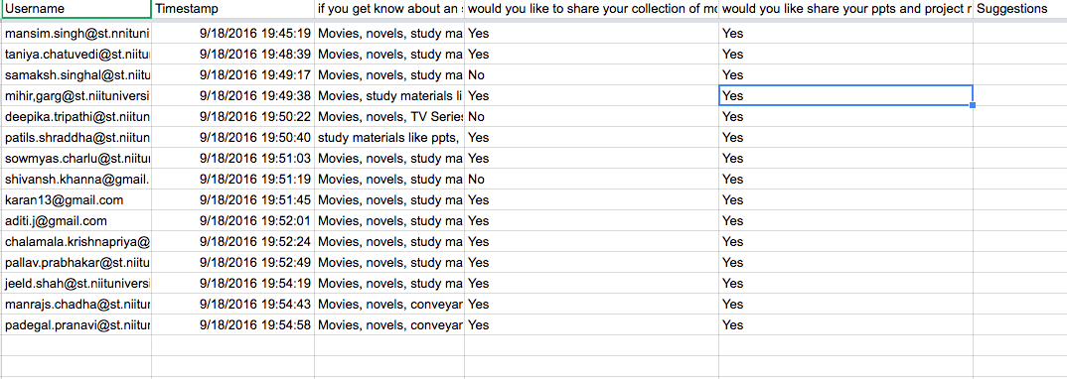
list of responces of the first survey

TECHNOLOGY CONSIDERATIONS
The software is built with the definition of following frameworks:
- The database is designed using the Mongo DB framework.
- The languages (html, CSS, java script, node JS) are built upon the Visual Studio 2015 Enterprise software.
- The software is majorly designed upon the Microsoft Windows OS. However, it is created as a cross-platform forum to work over Linux and iOS as well.
- The Node JS framework: Integration with other Visual Studio features and 3 rd party tools. (Node.js, io.js, JavaScript, TypeScript, HTML, CSS, and JSON support)
- Communication protocols that interface between the front-end and back-end codes.

The app doesn’t require much of the heavy/complicated software involvement to built up. The cost of working and developing are minimal and is designed as a cross platform open source implmentation that can verse well with all types of operating systems and defines a comprehendible/lucid interface for the user.

PRODUCT/SERVICE MARKETPLACE

The software has been designed majorly for University students. However, it can be generalized and extended to local area space where people can interact and share their entertainment, study material and conveyance through the app.
Here are the responses that have been recorded for the surveys:
The user can sign up through university/domain login and can share their email/contacts if they want so that other users can contact. Users are required to describe their interest in type of TV Series or particular movie or novel garner. The can share study materials ppts or pdf for the juniors. The user can sketch the details of their journey and check if anyone’s matches with theirs. Users can search for their needs under headings like entertainment, studies and conveyance and if their requirement matches with any uploaded ones can then contact the consent person. The user can send request to the consent person for his/her contact.

Survey form1 link:
https://docs.google.com/a/st.niituniversity.in/forms/d/e/1FAIpQLSdQRok8juXlh7KKhXiNcEUZWWn9YxTKTtLWmKertD9MFtg0fA/viewform

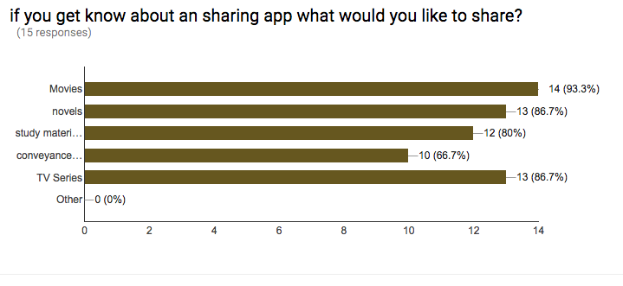

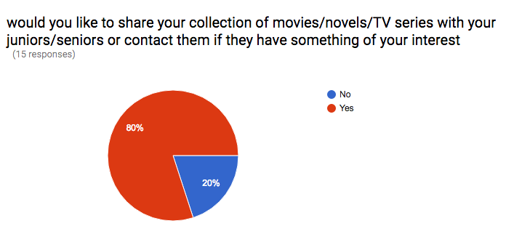

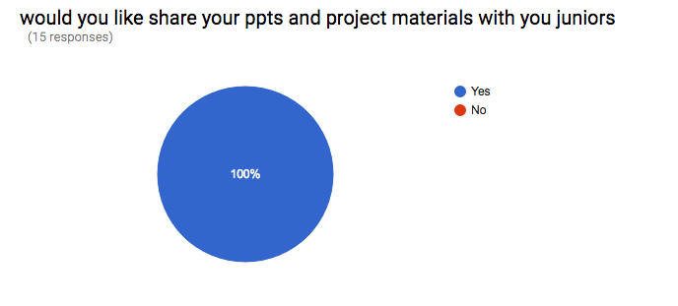

Survey form2 link:
https://drive.google.com/open?id=106nrUHpPJbuwHH0KGF8CrogIt4Tui3VpNfJ0K841ZL8

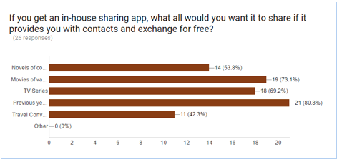

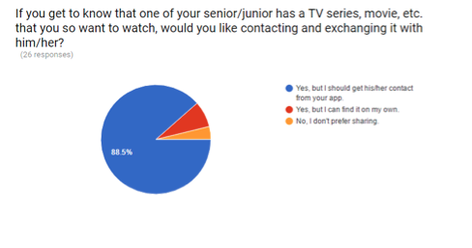

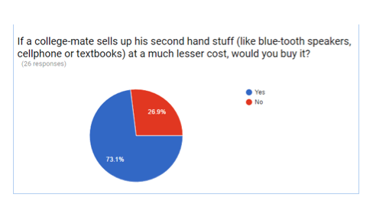

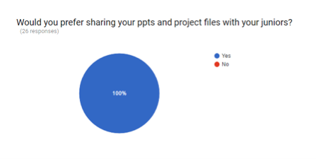

Some suggestions:
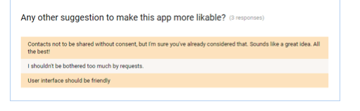

MARKETING STRATEGY
The app has been designed do that the users can interact and know other people beyond their friend circle. The app would be promoted on various social media platforms like facebook, twitter, Instagram etc.
Various posters will put up in near by colleges, universities and localities.

TREATS/POSSIBLE REASONS FOR NOT A SUCCESSFUL PRODUCT
- If customers are not interested in interacting with other people beyond their friend circle
- If the students are interested in sharing their means of entertainment or their contact or email id.

REFERENCES
- https://www.google.co.in/search?q=feasibility+analysis+pdf&oq=feas&aqs=chrome.1.69i59l3j69i57j0l2.3767j0j7&sourceid=chrome&ie=UTF-8
- http://thenextweb.com/apps/2015/07/10/9-of-the-best-apps-for-sharing-files-between-devices-and-friends/
- https://www.google.co.in/forms/about/
- https://teamtreehouse.com/tracks/front-end-web-development
- http://www.inc.com/murray-newlands/15-marketing-strategies-that-inspire-strategic-thinkers.html

CONCLUSIONS

The “Share Karo” App is getting a good response at its developing stage and its ready to be taken forward as working model.

